**Question 1 (Present your answers using PowerPoint slides)**

(a) Explain how usability measurements can be beneficial to both developers and customers.

For developer – Help to improve the prototype before we released to the market, determine when to stop prototyping and move on to the next stage of development. To track the progress of the prototype version, to asses the competitive position of your product – are you getting better or worse compared with others, make a go or stop decision for the product before launching.

For customers – Helps make comparison between products when making a purchasing decision for example android phone vs IOS

(b) What are the ways of measuring software usability?

For examples Task time, problem count, keystrokes count, opinion polls. We can measured the effectiveness, efficiency and satisfactions of the user (usability measurements)

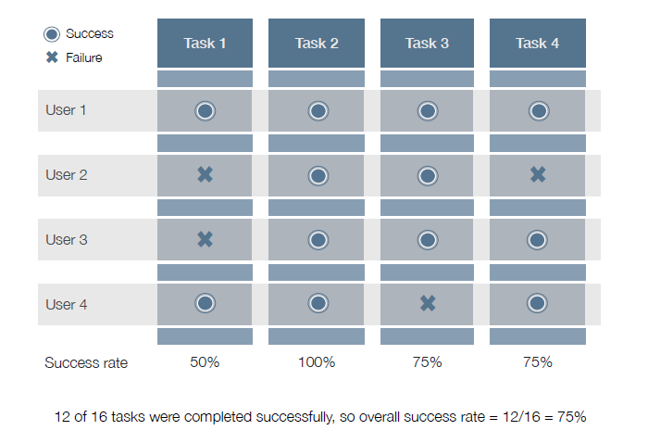

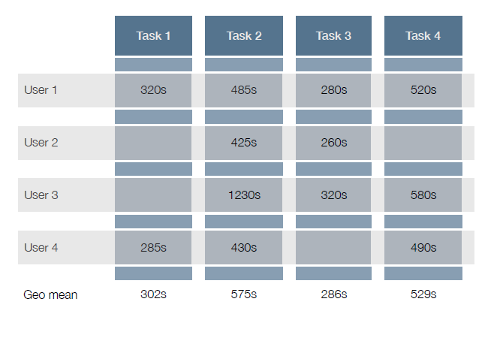

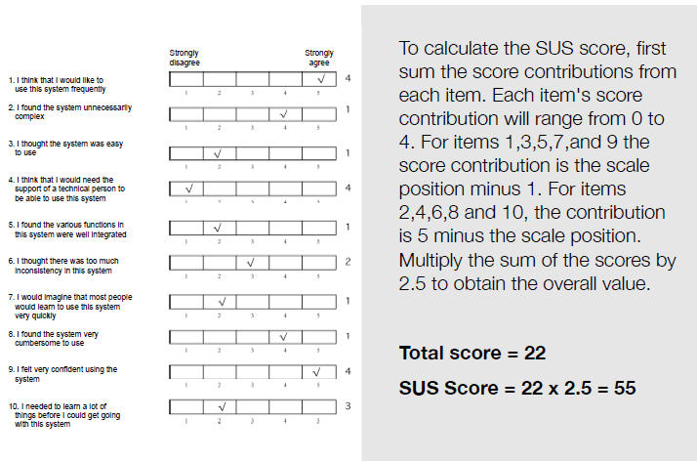

(c) Suggest suitable way(s) to measure the usability of your HCI assignment’s prototype. Justify your choice(s).

Adherence to guidelines or principles to measure how well the system follows correct rule sets such as the 8 golden rules, Nielsen 10 heuristics . In order to carry out the measurement, we can review the user interface of our prototype and identify deviation from guidelines or principles

* Measure time to complete task such as filling in form (effectiveness and effiencyy)

**Question 2 (Present your answers using PowerPoint slides)**

(a) What are the benefits of making the working environment ergonomically correct?

To ensure the **comfort, efficiency and safety in the working environment**

* To make the work **more** **comfortable**
* To improve workers productivities
* To improve both health and safety in the work place

When the working environments are well designed (ergonomically correct) employees will be:

* + happier & healthier
  + produce better work
  + quit job less frequently

(b) Describe the negative impact to workers as a result of a poorly designed working environment while at the same time they have to use a computer over a long period of time**.**

If the working environments are **poorly designed** **(ergonomically incorrect)** and using a computer over a long period of time**,** it can cause many types of illnesses/injuriesto the employees, e.g:

* + Repetitive strain injury (RSI)
  + Eyes disorders
  + Back & shoulder pain, etc

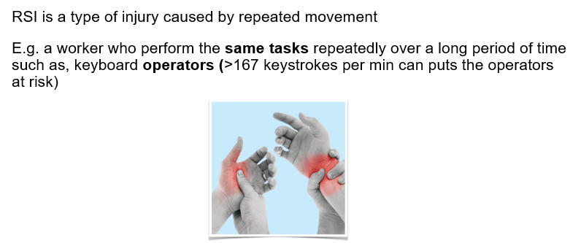

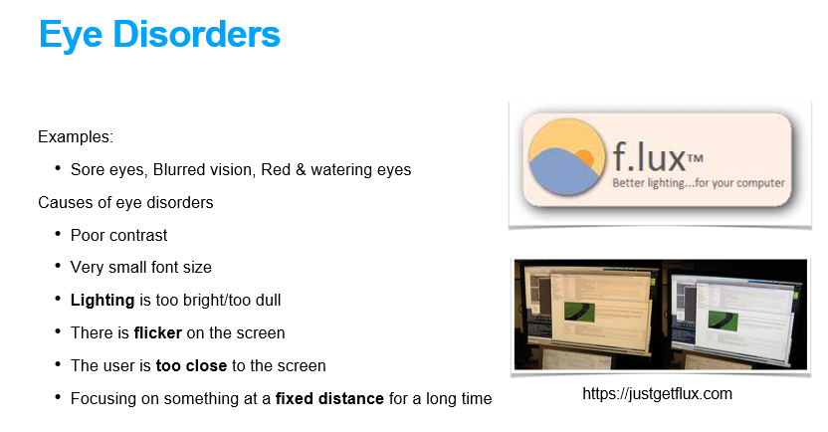

(c) Using your favourite browser search for “Google Office”. Create about 10-20 slides to illustrate the working environments in Google.Com. Include also some photos of working environments in 3 other companies for comparison purposes (one of them must be own your place of study). Explain your answer.

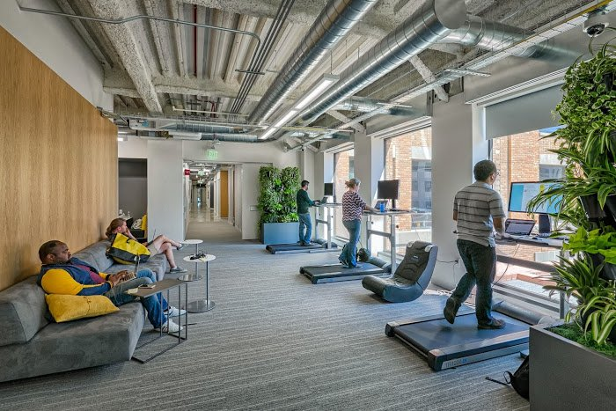

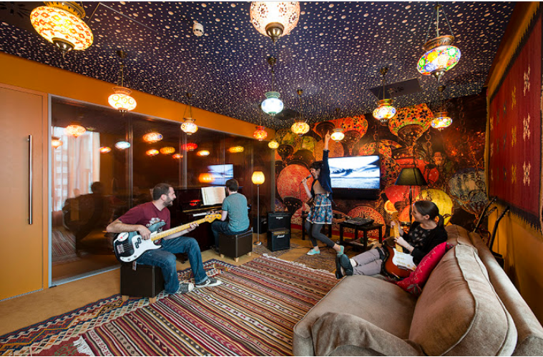





**Question 3 (Present your answers using PowerPoint slides)**

(a) The followings are important factors that need to be taken into account in order to create an ideal/wholesome working environment.

* Proper desks and chairs – to prevent back and shoulder pain
* Adequate lighting – to prevent eye discomfort
* Low noise level – too much noise can affect the concentration
* Temperature (15°C to 22°C) – too hot 🡪 sweating, cannot work, too cold 🡪 feel sleepy

Give reason(s) why each of the above factor is important to the office workers.

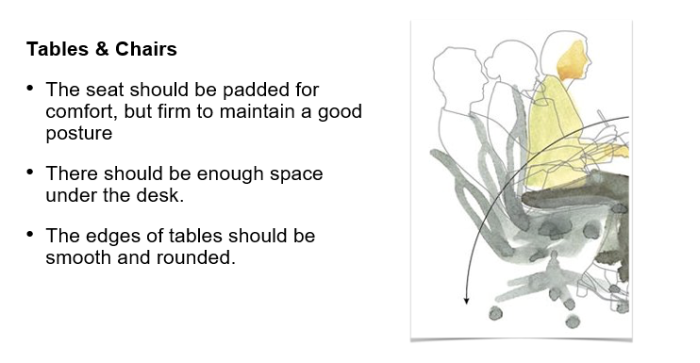

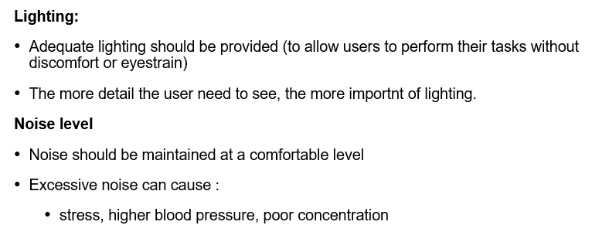

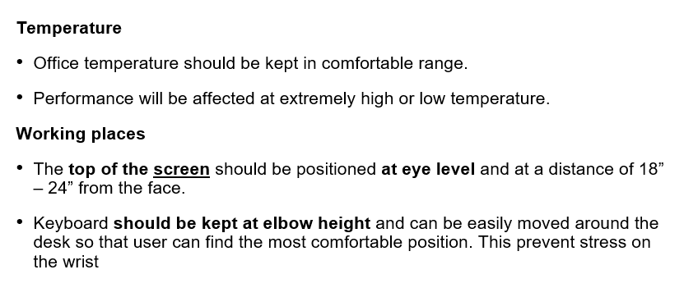

(b) Give one example (**own example**) of an incorrect sitting posture. Explain your answer.

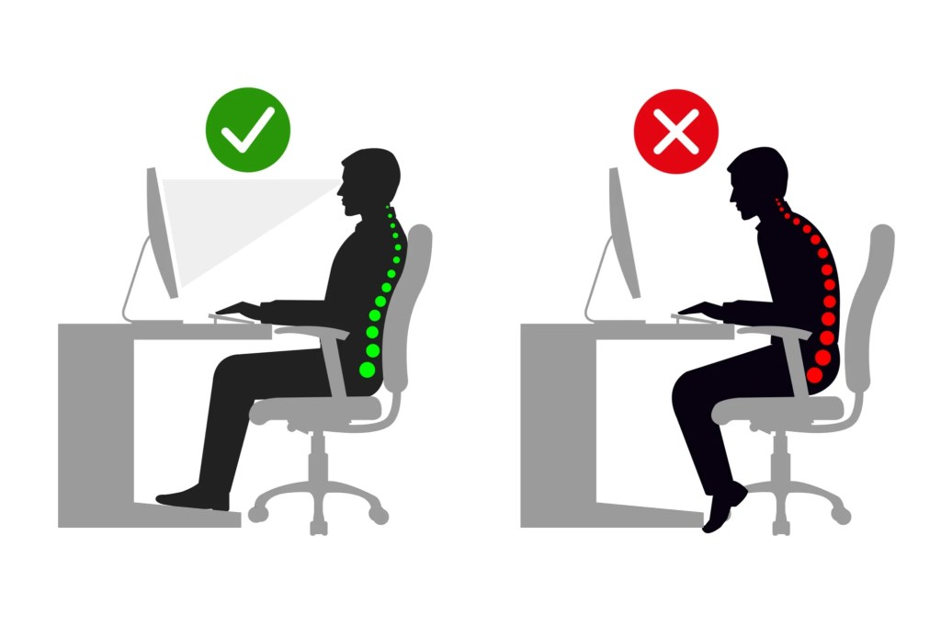

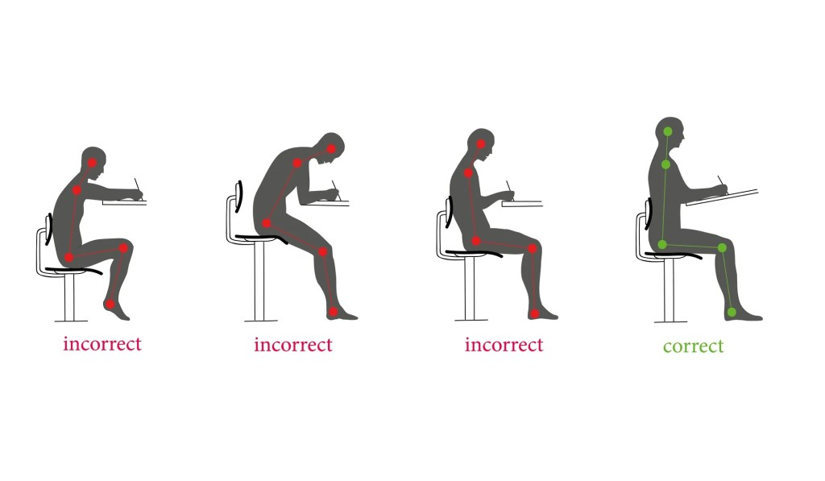 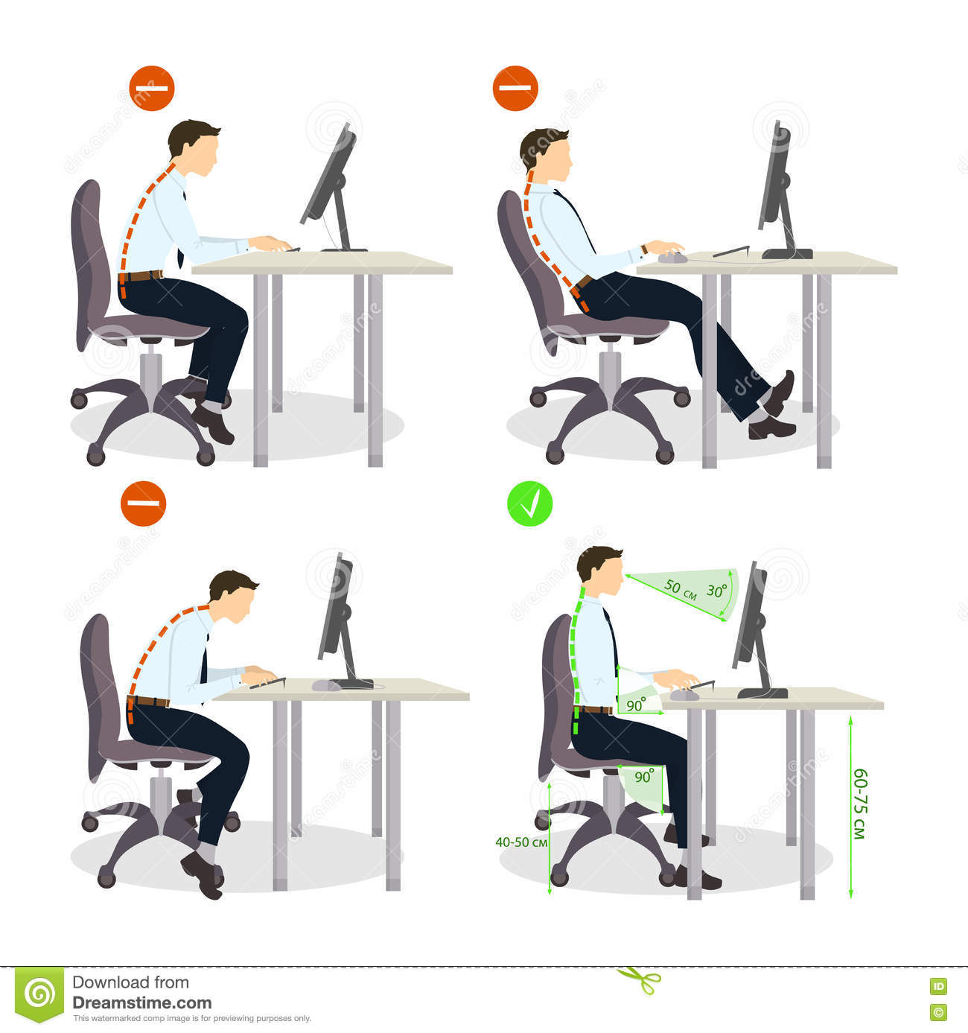

(c) Give one example (**own example**) of a correct sitting posture. Explain your answer.

*Note: For Q3(b) and Q3(c), search the Internet/textbook for the required answers.*

***- End -***